Sunday | Monday | Tuesday | Wednesday | Thursday | Friday | Saturday
 |  |  | 1  Yom Kippur Begins | 2 | 3 | 4
5 | 6  Sukkot Begins | 7 | 8 | 9 | 10 | 11
12 | 13  Thanksgiving Day (Canada)  Indigenous Peoples’ Day  Columbus Day (U.S.) | 14  Simchat Torah Begins | 15 | 16 | 17 | 18
19 | 20 | 21 | 22 | 23 | 24 | 25
26 | 27 | 28 | 29 | 30 | 31  Halloween

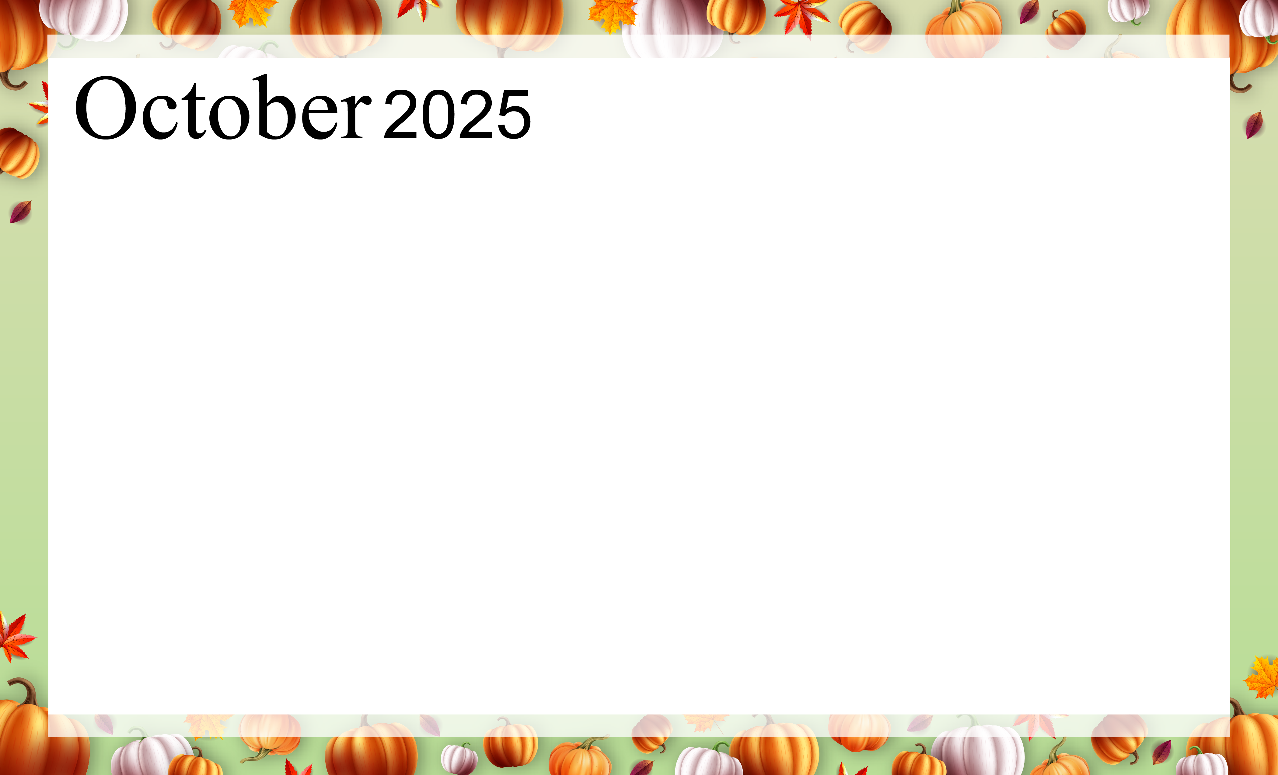  COURT, Ecumen, St. Benedict’s Community |  |  | 9:50-Morning Stretch  Community Room  11:00 – Mass, Fr. David  1:30 – Bingo/Great Rm  2:30 – Coffee & Cookies  Great Room  6:00-Yahtzee/Fireside Rm | 10:30 – Coffee Time  Fire Side Room  1:15 – “Scenic Relaxation Film of Iceland”/ theater  3:30 – Piano Music with  Dave/Front Lobby  6:00 – Card Group with  Tina/Fireside Rm | 9:50 – Morning Stretch  Community Room  1:30 – Music with the River City Ramblers  in the Great Room | 1:30 – Bingo/Great Rm  2:30 – Movie Theater  “Geronimo”  4:00 – Music with  George/Front Lobby
1:00 – Mass, Fr. David | 9:30-Walmart Outing  1:15 – “Country Music” by  Ken Burns, episode 2  in the theater  1:30 – Bingo/Great Rm  2:45 - Men’s Group/GR  4:00 – Rosary/Chapel  6:00 – “500”Cards/FR | 3:00 – Chronology  Word Game/Great Rm  6:00 – Farkle/Fireside | 9:50-Morning Stretch  Community Room  10:45 – Protestant  Church, Deacon Matthew  2:00 – Tenant Meeting  Great Room  6:00 – Mexican Domino  Fireside Room | 10:30 – Coffee Time  Fire Side Room  11:00-Mass, Fr. Barnes  1:15 – “Country Music” by  Ken Burns, episode 2  in the theater  6:00 – Card Group with  Tina/Fireside Rm | 9:50 – Morning Stretch  Community Room  1:30 – Pattern Bingo  Great Room | 2:30 – Movie Theater  “The Illusionist”
1:00 – Mass, Fr. David  2:30 – Bingo/Great Rm | 9:30 – Cub Outing  1:30 – Bingo/Great Rm  4:00 – Rosary/Chapel  6:00 – “500”Cards/FR | 9:30 – Bible Study/CR  10:45 – Protestant  Church, Pastor Kay  3:00 – Scattergories  Word Game/Great Rm  6:00 – Farkle/Fireside | 11:00 – Mass, Fr. David  1:30 – Accordion Music with Bill Koncar  in theGreat Room  6:00 – Yahtzee/Fireside | 10:30 – Coffee Time  Fire Side Room  6:00 – Card Group with  Tina/Fireside Rm | 1:30 – Movie  Robert Redford in  “The Sting” | 1:30 – Bingo/Great Rm  2:30 – Movie Theater  “Dragonfly”
12:00 – Vikings vs  Philadelphia/theater  1:00 – Mass, Fr. David | 9:30 – Dollar Store  1:15 - “New England Fall Foliage”/ theater  1:30 – Bingo/Great Rm  4:00 – Rosary/Chapel  6:00 – “500”Cards/FR | 10:45 – Lunch Outing  To Applebee’s  2:45 – Autumn Craft  Community Rm  6:00 – Farkle/Fireside | 9:50-Morning Stretch  Community Room  10:45 – Protestant  Church, Deacon Matthew  1:30 – Bingo/Great Rm  2:30 – Happy Hour/GR  6:00 – Mexican Domino  Fireside Room | 11:00 – Mass, Fr. Mike  6:00 – Card Group with  Tina/Fireside Rm | 1:30 – Allen Carlson  Music/Great Room | 1:30 – Ladies Movie  in the theater  “Wicked”
1:00 – Mass, Fr. David  2:30 – Bingo/Great Rm | 9:30 – Target Outing  1:15 – “MN in the  1970’s/ theater  1:30 – Bingo/Great Rm  4:00 – Rosary/Chapel  6:00 – “500”Cards/FR | 9:30 – Bible Study/CR  10:45 – Protestant  Church, Pastor Kay  3:00 - Making Halloween Treats/Comm Room  6:00 – Farkle/Fireside | 9:50-Morning Stretch  Community Room  11:00 - Mass, Fr. David  1:30 – Bingo/Great Rm  2:30 – Cake & Ice Cream  Birthday Social, GR  6:00 – Yahtzee/Fireside | 10:30 – Coffee Time  Fireside Room  6:00 – Card Group with  Tina/Fireside Rm | 10:45 - Trick or Treaters/Great Room  1:30 – Bingo/Great Rm | KEY:  GR = Great Room  FR = Fireside Room  CR = Community Room
ALL ACTIVITIES ARE SUBJECT TO CHANGE

